**Title: Intercomparison and validation of ERA5, ERA5-Land and AROME against in-situ measurements for wind energy applications over Reunion Island**

**Author:** Liliane Uwajeneza

**Supervisor**: Dr. Béatrice Morel, Dr .Chao Tang, Dr. Bamba Mouhamadou Sylla

**ABSTRACT**

To ensure energy autonomy, initiatives aiming at mitigating emissions of greenhouse gases in the energy sector rely on the development of renewable energy sources (RES). However, integrating electric RES into the energy mix represents an important challenge due to the variations they undergo, and which induce variations in the electricity production that are not always in phase with demand. This is the case for wind energy whose production varies according to the meteorological and climate conditions. The key goal of the present study is to provide a wind resource assessment over Reunion, a small island located in the South West Indian Ocean (SWIO) whose objective is to become self-sufficient for its electricity with RES by 2030. If the development of wind energy on the island has been limited to two wind farms up to now, Reunion’s plan for making its electricity system 100% renewable includes new installations of both onshore and offshore wind capacity.  
In this study, the wind data from a variety of gridded datasets including climate reanalysis ERA5 at ~25 km spatial resolution and ERA5-Land at ~9 km spatial resolution, along with Météo-France AROME model at ~2.5 km spatial resolution are compared and validated against in-situ measurements from different Météo-France sites across Reunion over the period 2017-2020. All datasets are recorded at 10m height with an hourly temporal resolution. The validation is conducted ~~over different time scales~~ from the annual means to the diurnal cycles and includes visual (Weibull frequency distribution, time series of annual and diurnal cycles) and computational (correlation and metrics such as the bias and the root-mean-square error to quantify the errors) methods.

1. **Introduction**

**2. Data**

This section goes through the data used in this study.

**2.1 In-situ measurements**

For this work, we used wind data from Météo-France recorded between 2017 and 2020 at a height of 10 m above sea level. Table 1 shows the stations that were used to determine the wind resource across La Réunion. All stations were used to describe the annual mean wind speed of La Réunion. However, 7 stations are only selected to be used for the diurnal and seasonal cycles.

**[Table 1: Stations of wind data used in this study over  
 La Réunion](#D2L_table_label_Stations  of wind data used in this study over La Réunion )**

|  |  |  |  |
| --- | --- | --- | --- |
| **Station** | **Longitude (°E)** | **Latitude (°S)** | **Altitude (m)** |
| BELLEVUE BRAS-PANON | 55.623 | -21.005 | 480 |
| PONT-MATHURIN | 55.38 | -21.265 | 19 |
| PLAINE DES PALMISTES | 55.627 | -21.136 | 1032 |
| LE PORT | 55.282 | -20.946 | 9 |
| SAINT-BENOIT | 55.719 | -21.059 | 43 |
| COLIMACONS | 55.305 | -21.13 | 798 |
| PETITE-FRANCE | 55.342 | -21.045 | 1200 |
| PITON-MAIDO | 55.381 | -21.077 | 2150 |
| POINTE DES TROIS-BASSINS | 55.248 | -21.105 | 5 |
| PIERREFONDS-AÉROPORT | 55.426 | -21.32 | 21 |
| LE BARIL | 55.732 | -21.36 | 115 |
| GILLOT-AEROPORT | 55.524 | -20.889 | 8 |
| GROS PITON SAINTE-ROSE | 55.829 | -21.18 | 181 |
| BELLECOMBE-JACOB | 55.687 | -21.218 | 2245 |
| PLAINE DES CAFRES | 55.573 | -21.209 | 1560 |
| CILAOS | 55.472 | -21.134 | 1197 |

**2.2 Gridded datasets**

Various gridded datasets used in this study are global climate reanalysis coming from ERA5 on a single level and having a spatial resolution of 25 km, and ERA5-Land has a spatial resolution of 9 km [2]. These two datasets are produced by combining observations with simulated data in order to obtain the most realistic possible description of meteorological phenomena by using the laws of physics. ERA5 provides the wind data for land and ocean at a height of 10 m and 100 m, while ERA5-Land provides only for land at a height of 10 m. Both have the same temporal resolution (Hourly). The AROME model also used in this study has a spatial resolution of 2.5 km produced by Météo France. All datasets' wind data are at a height of 10 m. The summary and characteristics of the [numerical datasets](#D2L_table_label_Information on the numerical datasets evaluated in the study.) used are displayed in [Table 2](#D2L_table_ref_Information on the numerical datasets evaluated in the study.).

[**Table 2: Information on the numerical datasets evaluated in the study.**](#D2L_table_label_Information on the numerical datasets evaluated in the study.)

|  |  |  |  |  |  |
| --- | --- | --- | --- | --- | --- |
| **Dataset** | **Type** | **Variable** | **Study period** | **Temporal Resolution** | **Spatial Resolution** |
| ERA5 | Reanalysis | U10, V10 | 2017-2020 | 1h | 25 km |
| ERA5 Land | Reanalysis | U10, V10 | 2017-2020 | 1h | 9 km |
| AROME | Model | U10, V10 | 2017-2020 | 1h | 2.5 km |

**3. Methodology**

This section presents the methods and mathematical equations used to explore the results. All datasets' wind data were collected at a height of 10 m. From the wind components U (eastward component) and V (northward component), we computed the wind speed and direction. To compare modeled and observed wind speeds. In Section 3.1, the extrapolation of wind speed at hub height was performed using the logarithmic law. To describe the variation in wind speed at each site the weibull frequency distribution was used (Sect 3.1). Wind power density was used to measure the wind energy available to the site given in this study (Sect 3.3).

**3.1 Extrapolation wind speed at different hub-heights**

The data of wind speed and direction was computed from U10 and V10. For obtaining the data at different hub-heights, to extrapolate wind speeds at reference height we used logarithmic profile (log low), in this study we are interested in finding the wind speed at heights 50 m, and 100 m. The equation of logarithmic low used to calculate the vertical wind profile for different altitudes and (eq 1):

= (1)

Where =10m, =100m, is the surface roughness lengths for various terrain types. can be derived From (eq 1), can be written as:

= (2)

For computing the surface roughness **(**), we used data from ERA5 reanalysis, where is the wind speed at height of 10 m and is the wind speed at height of 100 m.

Then () obtained can be used in an (eq 3) to extrapolate wind at different altitudes z (m).

V(z)=V() (3)

Where is the wind speed at desired height (m/s), is the reference wind speed at height (m), z(m)is the desired height, is the height of the station in relation to the ground, in this study we used (=10).

**3.2 Weibull frequency distribution**

Probability density functions (PDFs) are mostly used to describe the distribution wind speed in order to choose the best turbines for a specific region. The weibull distribution is often a good approximation for the wind speed distribution, in different areas (CITE) used for the estimation of Weibull parameters for wind energy analysis. The probability density function requires the two-parameter shape and scale. The Weibull PDFs and cumulative distribution are given by:

(4)

(5)

Where, is a shape parameter, is a scale parameter in units of wind speed (m/s).The weibull scale and shape parameters are calculate using

c=

**3.3 Wind power density (WPD)**

The wind power generated by wind turbines is related to the cube of wind speed (v) and air density (). WPD is the one considered to determine the wind energy for any location other than the wind speed.

The mathematical equation used for calculating the wind power density (WPD).

(4)

Where is the wind speed in m/s, and is the air density in kg/. This study we computed the air density at local and height of interest by using the equation (5):

(5)

Where is the altitude and is the surface temperature.

|  |  |
| --- | --- |
|  |  |

**4. Results and Discussion**

In this section, we will visualize the results obtained from methodologies using Python software to perform the data analysis and visualization.

[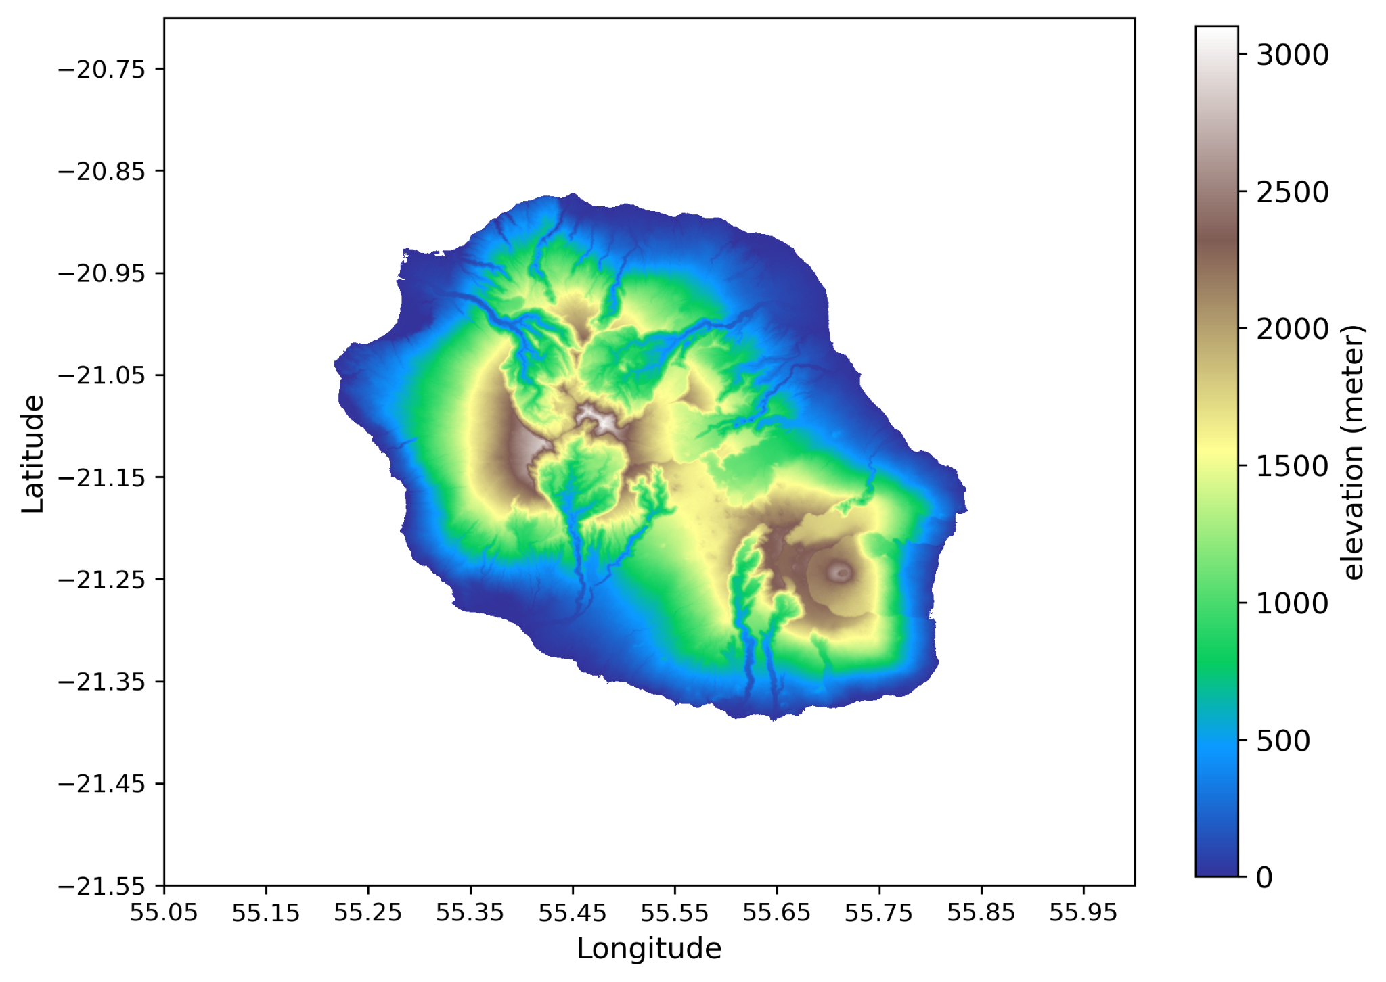](#D2L_fig_label_Topography of  La Réunion)  
Figure 1: Topography of La Réunion

[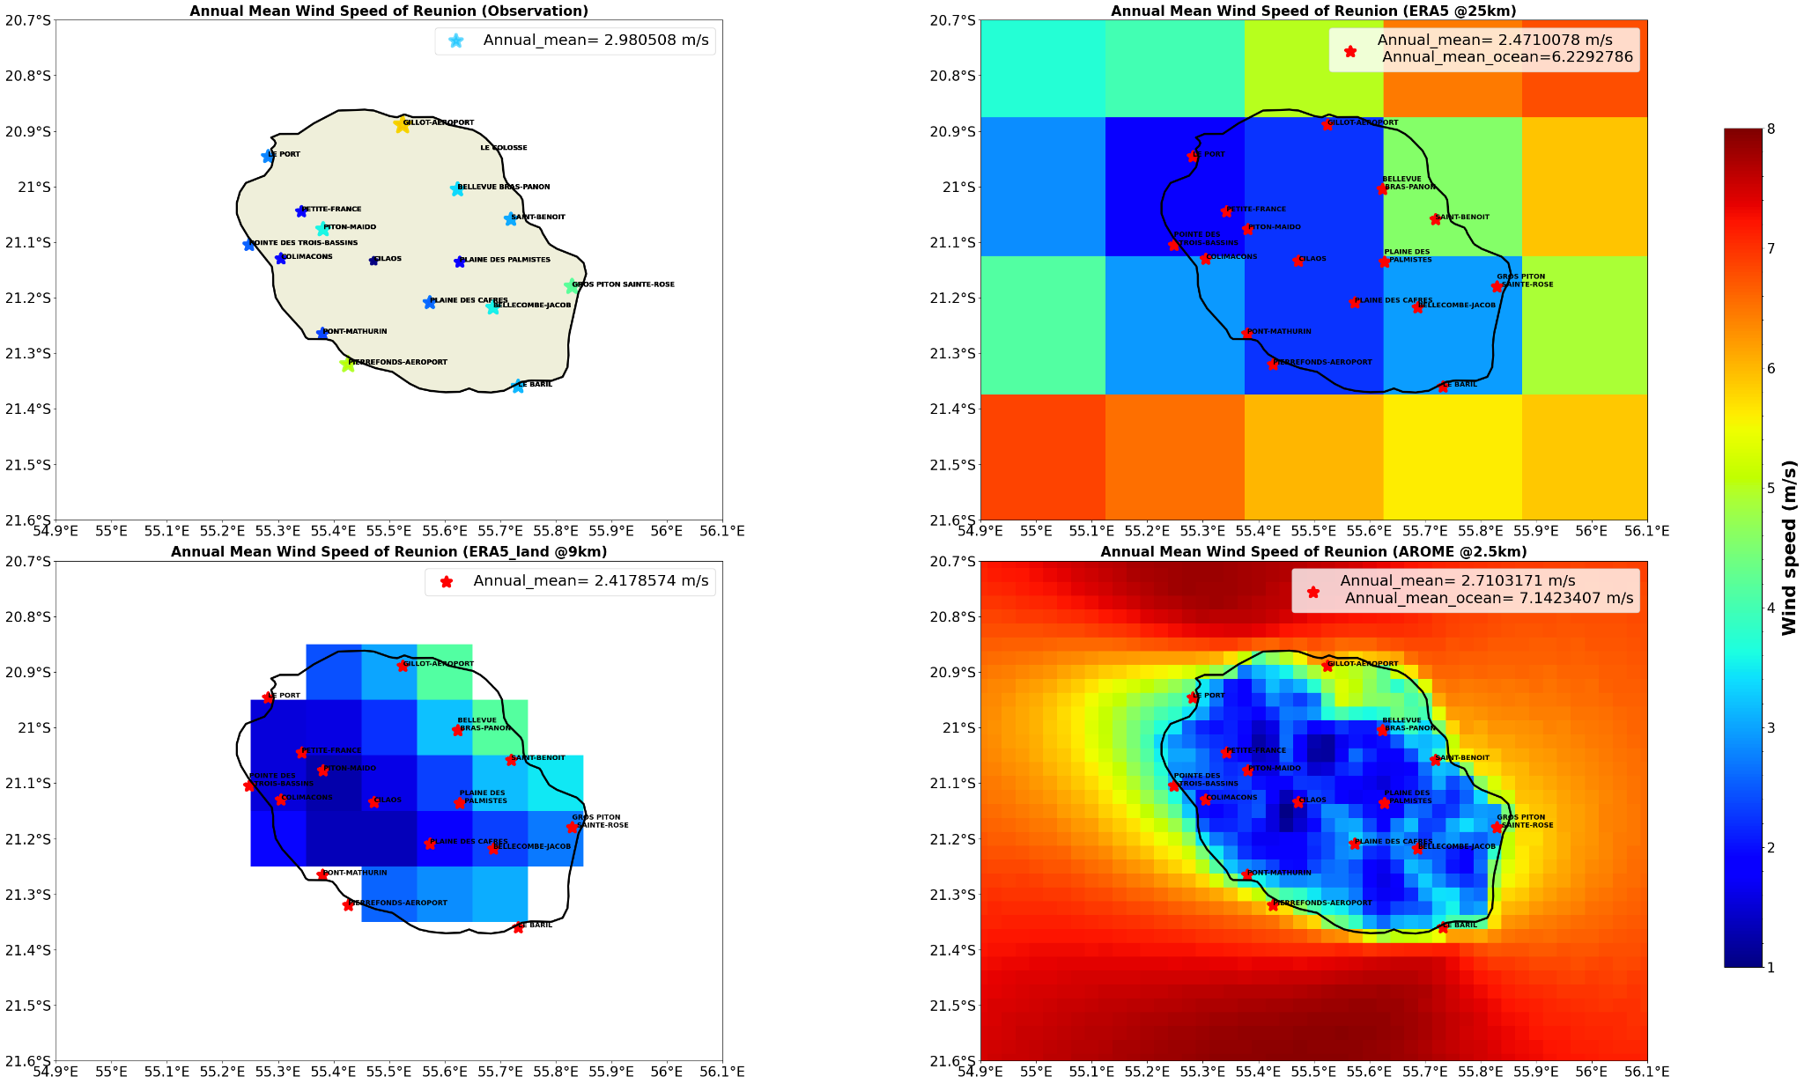](#D2L_fig_label_Annual mean wind speed  at 10 m  of La Reunion for Observational data , ERA5, ERA5 Land reanalysis datasets and AROME model)

Figure 2: Annual mean wind speed at 10 m of La Reunion for Observational data, ERA5, ERA5 Land reanalysis datasets, and AROME model

|  |  |  |
| --- | --- | --- |
|  | **Spatial std** | **Spatial Mean** |
| **Observation** | 2.263214 | 2.98057 |
| **ERA5** | 1.18193539 | 2.4710066 |
| **ERA5_Land** | 1.4632559 | 2.41785739 |
| **AROME** | 1.97656 | 2.710317 |

[Table 2: Spatial variability and mean for all datasets.](#D2L_table_label_Spatial variability and mean for all datasets.             )

[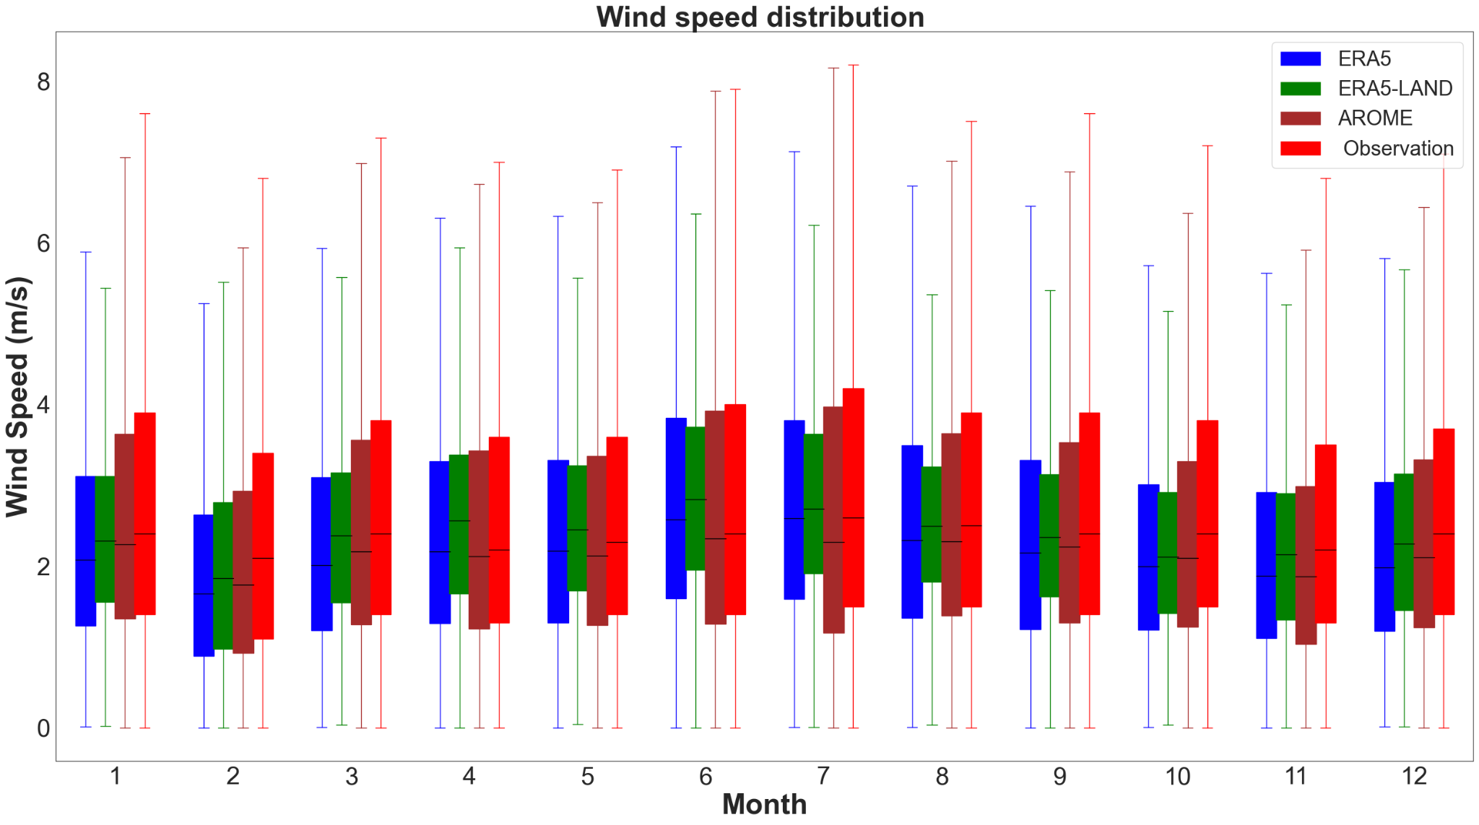](#D2L_fig_label_Seasonal  cycle of wind speed  (Monthly mean) over La Réunion)  
Figure 3: Seasonal cycle of (hourly or daily ?) wind speed averaged over the land of Reunion

[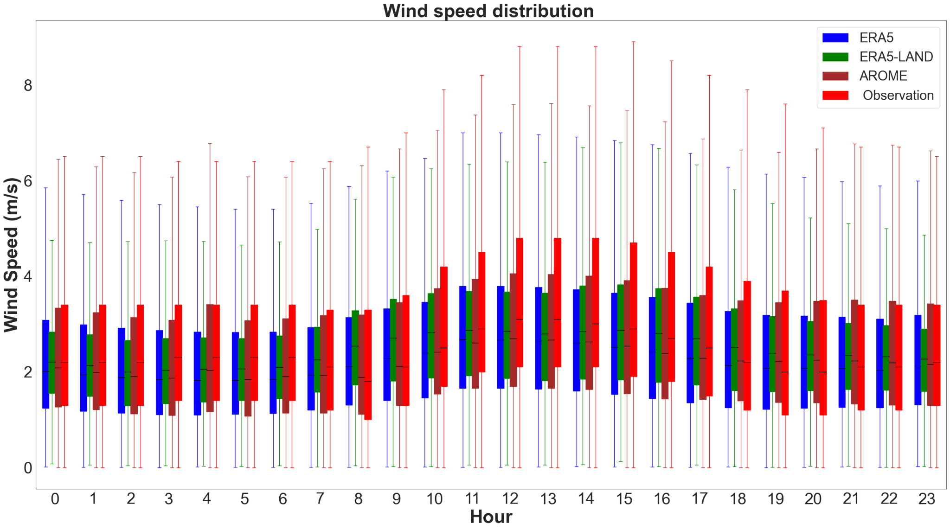](#D2L_fig_label_Diurnal  cycle of wind speed   over La Réunion)  
Figure 4: Diurnal cycle of wind speed over La Réunion.

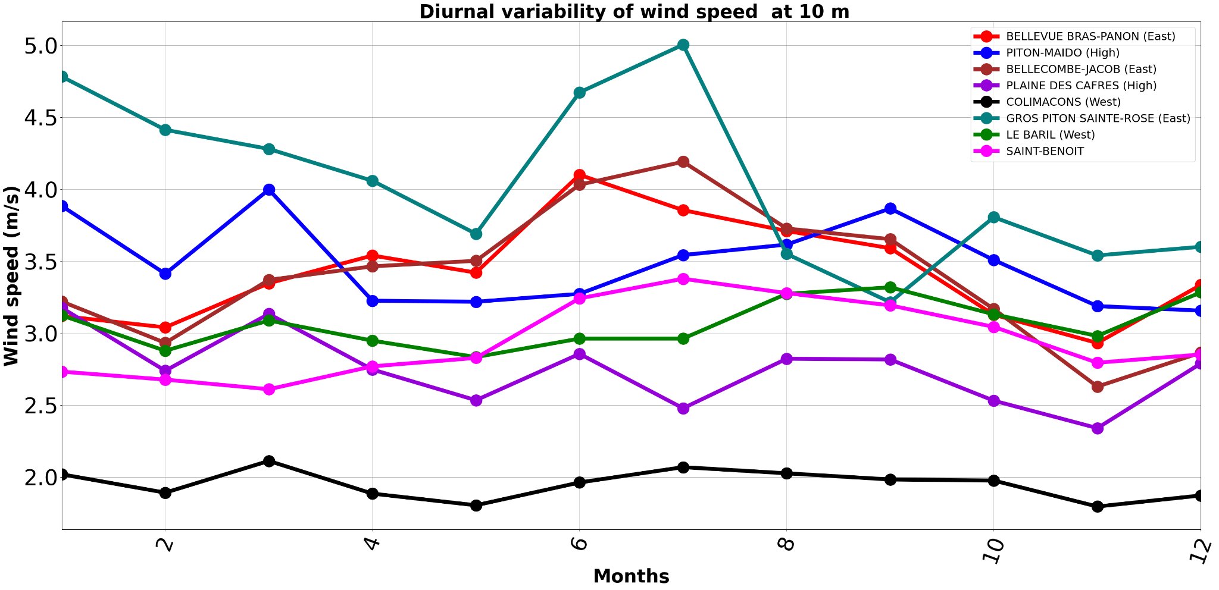  
Figure 5: Seasonal cycle of wind speed (Monthly mean) at each site chosen.

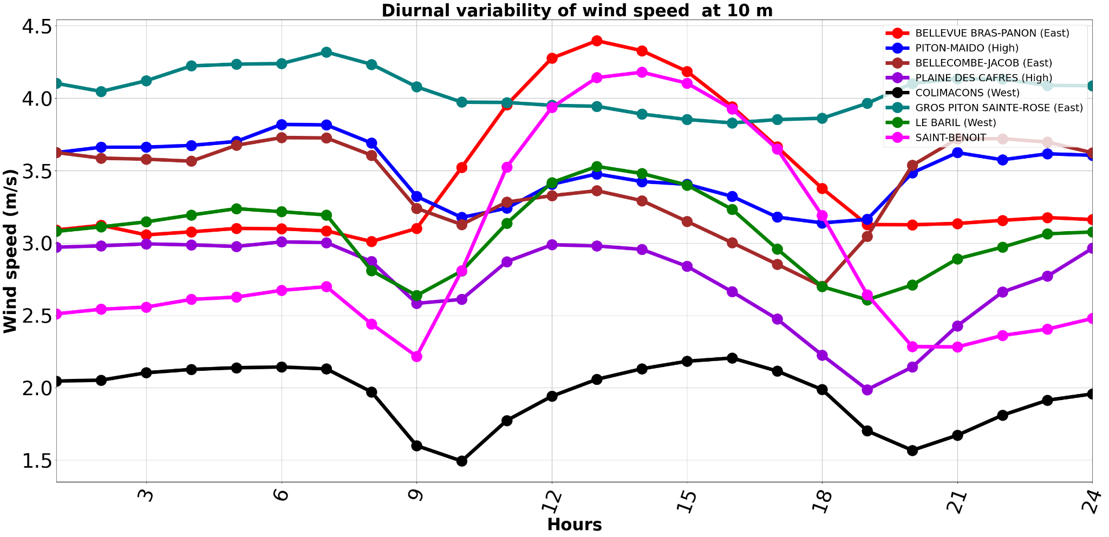  
Figure 6: Diurnal cycle of wind speed (daily mean) at each site chosen.

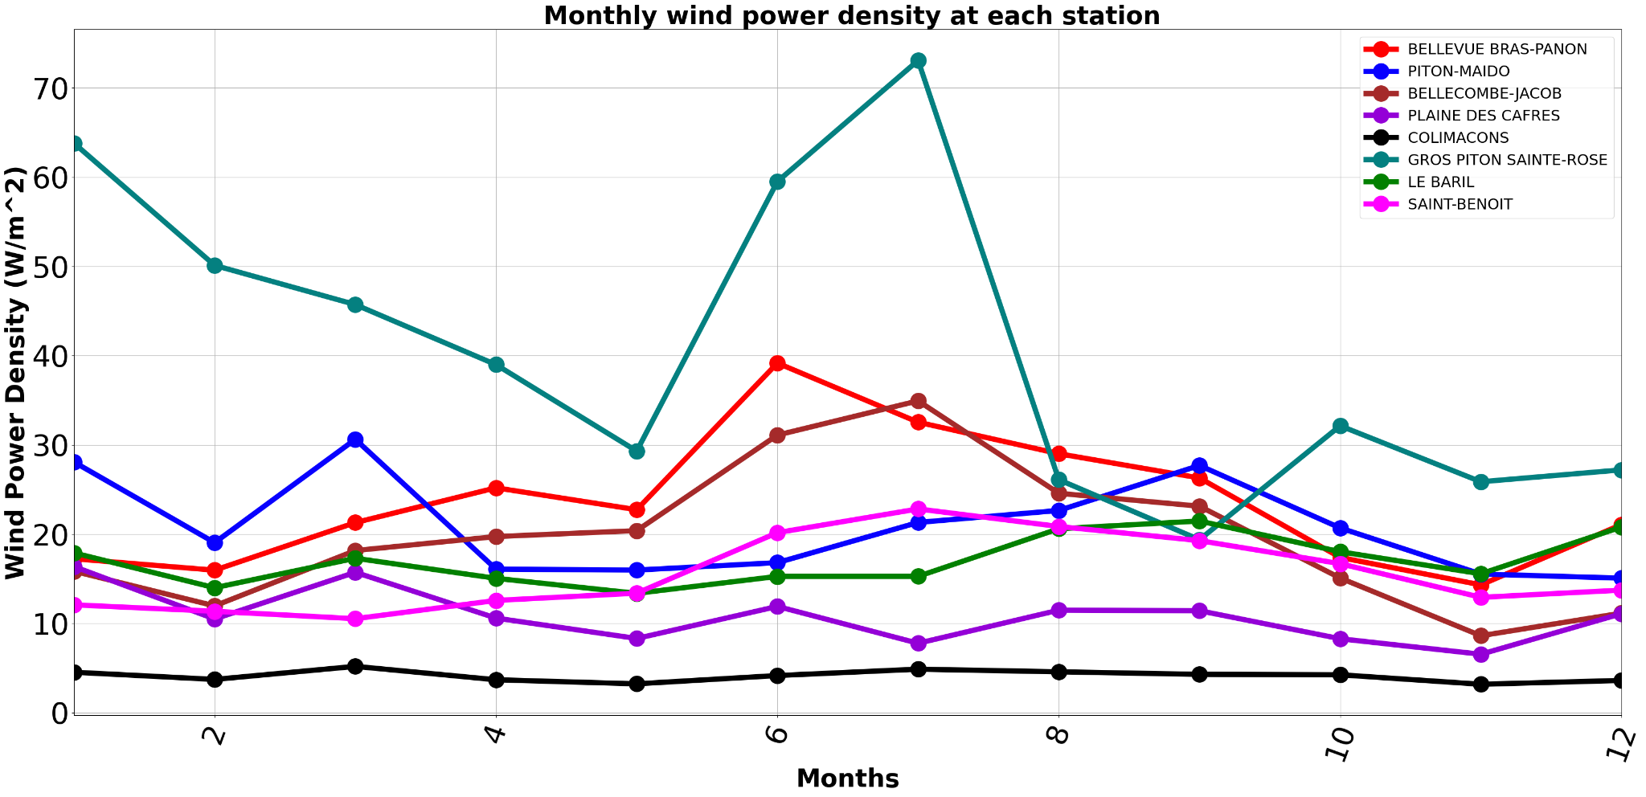

**5.Conclusion**

Bibliography

[1] M. Hopuare, T. Manni, V. Laurent, and K. Maamaatuaiahutapu, “Investigating Wind Energy Potential in Tahiti, French Polynesia,” *Energies*, vol. 15, no. 6, p. 2090, Mar. 2022, doi: <https://doi.org/10.3390/en15062090>.

[2] “Copernicus Climate Data Store ,” *cds.climate.copernicus.eu*. [https://cds.climate.copernicus.eu/cdsapp#](https://cds.climate.copernicus.eu/cdsapp)